**LIBRARY MANAGEMENT SOFTWARE**

***SEQUENCE DIAGRAM***

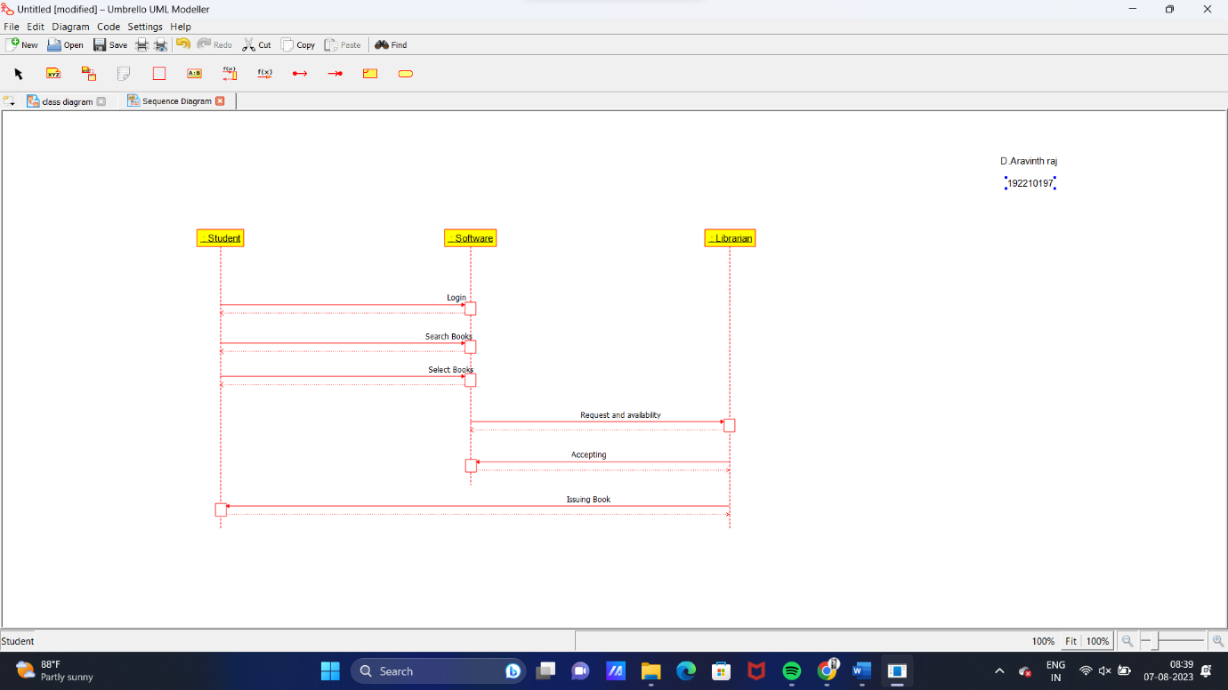

***STATE DIAGRAM***

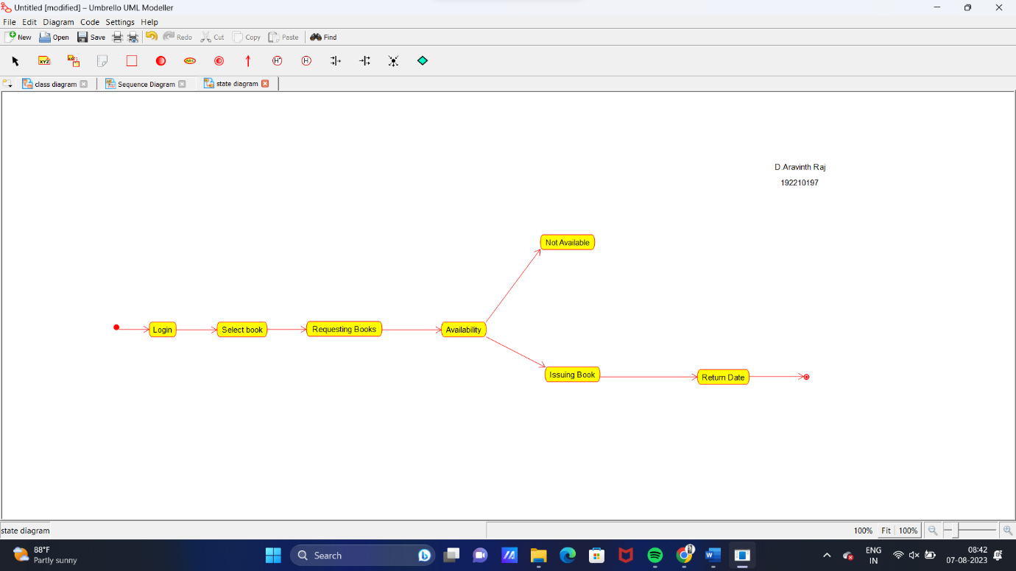

***DEPLOYMENT DIAGRAM***

